EUROPEAN SOCIAL CHARTER (REVISED)
Strasbourg, 3.V.1996
Georgia
Report 2020
On the implementation of the Articles:

Article 3 - The right to safe and healthy working conditions
Article 11 - The right to protection of health
Article 12 - The right to social security
Article 13 - The right to social and medical assistance
Article 14 - The right to benefit from social welfare services
Article 23 (or Article 4 of the of the Additional Protocol) – The right of elderly persons to social protection
Article 30 - The right to protection against poverty and social exclusion

Article 3 – The right to safe and healthy working conditions
GoG response:
For the last years, Georgia has undergone deep changes in its labour legislation and institutions. Ministry of Internally Displaced Persons from the Occupied Territories, Health, Labour, and Social Affairs undertook concrete steps to elaborate special mechanism to ensure inspection on working conditions at workplaces and re-establish an Office of Labour Inspection (no mechanisms since 2006). The mechanism which is equipped with corresponding administrative and executive rights and is progressively introducing the International Labour Organization’s standards. The Labour Conditions Inspecting Department was established under Ministry of Internally Displaced Persons from the Occupied Territories, Health, Labour, and Social Affairs in March 2015. Since then the Government’s top priority was provision of decent working conditions for all Georgian workers.

In 2018, Georgia passed legislation to provide Occupational Safety and Health (OSH) protections for workers employed in hazardous industries and adopted a Law on „Occupational Safety”. The Law entered into force on 1 August 2018. In order to give full effect to the OSH protections, the Parliament of Georgia adopted a new Organic Law of Georgia on “Occupational Safety” (February 2019). Transforming OSH law into an organic law makes it more resilient to political interference, fluctuations and guarantees establishment of effective labour rights protection system. New law extended mandate of labour inspectors which implies that labour inspectors are entitled to conduct unannounced inspections (without court order) in enterprises in all economic sectors and impose sanctions on identified violations, which entered into force on September 1, 2019 and applies to all workers including public sector and public officials.
In 2019 number of labour inspectors increased from 25 to 40 and two divisions were established, Inspection Division and Monitoring and Supervision Division. The Labour inspection budget doubled in 2020 and GoG adopted a Decree (January 16, 2020; N82) to further increase the number of labour inspectors to 100. Now, LCID has 67 labour inspectors, out of which 61 are carrying out inspections related to OSH matters while 6 of them are working on the Labour Code violations. Labour inspectors are being constantly trained and retrained. Besides the capacity building activities for the labour inspectors, a lot of technical assistance has been provided. Department was equipped with body cameras, tablets, computers, work uniforms, special boots, helmets, etc. With the support of GIZ’s PSD TVET program the Ministry developed and presented the mobile app “Construction Safety”. The app includes regulatory documents, hazardous situations, safety measures and technical instructions with illustrations. In order for the LCID to work electronically and create an effective business process, with the support of International Labour Organisation work on Labour Inspection Management System has started. This online platform will help Management elaborate detailed reports based on the information gathered during inspections. Test of the first version of the program is planned in the first quarter of 2021. In order to facilitate the inspection process, Labour Inspectorate is working on development of internal procedural mechanism. To this end, a number of decrees are being developed.
Forced labour, including, child labour is being monitored by the Labour Conditions Inspecting Department since 2016, labour officials are authorized to inspect labour conditions (unannounced) with the aim to identify and respond the violation/possible cases of forced labour/labour exploitation. Labour Conditions Inspecting Department is authorized to inspect the labour conditions with the aim to identify and respond the violations. It means that the labour inspectors have ability and power to ensure the proactive supervision mandatorily and not voluntarily. This contributes to effective planning and implementation of measures for prevention of forced labour and labour exploitation, as well as the promoting the identification and increasing the efficiency of combating the human trafficking. State supervision, along with other issues, covers inspection of companies in terms of revealing and preventing probable facts/cases of child labour/forced labour. In 2020, only one case of child labour was revealed and case was referred to the Ministry of Internal Affairs of Georgia (MoIA) for further investigation. In case of child labour, LCID uses suspension of working process and referral mechanism to Ministry of Internal affairs and LEPL Agency for State Care and Assistance For the (Statutory) Victims of Human Trafficking. Article 5 (6) Organic Law of Georgia on “Occupational Safety” determines that “employer shall not employ a person younger than 18 years old on the positions, which considering the nature and circumstances of the work, can cause harm to the health and safety of the minor.” Accordingly, the Ministry of the Internally Displaced Persons from the Occupied Territories, Labour, Health, and Social Affairs of Georgia in consultation with the social partners elaborated the list of such works, which was approved by the Decree of the Minister of Internally Displaced Persons from the Occupied Territories, Labour, Health, and Social Affairs. The Decree determines those physical, chemical, and biological, psychosocial and ergonomic factors, which might have an impact on minor’s health, growth and development. The Decree defines those working environments when employment of minor is not allowed (for instance, height, weight, temperature, etc.) and a list of such works that can cause harm to the development of the minor (physical, psychological). Besides that, the Decree provides a definition of light work. Particularly, pursuant to the Decree, light work is any type of work except working in manufacturing, which might not harm safety, health or development of a person younger than 18 and might not hinder the process of education and schooling, participation in vocational education programs. The labour inspection will ensure and supervise enforcement of the decree.
Government realized that there were remaining legislative and policy gaps related to protection of Georgian workers, hence continued to harmonize its legal framework with international standards, introducing amendments in 2019 and 2020. Amendments that was made on February 19, 2019 established principles that serve to eliminate and prohibit discrimination in labour and pre-contractual relations, introducing definitions of sexual harassment at workplace as the form of discrimination. The amendments were made to organic Law of Georgia “Georgian Labour Code”, Law of Georgia on “Elimination of All Forms of Discrimination”, Law of Georgia on “Public Service”, and Law of Georgia on “Gender Equality”.
On September 29 2020 the Parliament of Georgia voted for amendments to the Organic Law of Georgia “Georgian Labour Code” and adoption of the new Law of Georgia on “Labour Inspection”.
Amendments to the Labour Code outstandingly strengthen the legal framework for the protection of the labour rights of Georgian workers by meeting the requirements of GSP (generalized system of preferences), EU-Georgia Association Agreement and International Labour Organization. The amendments introduce a broad range of labour rights/norms. Apart from that, Georgian Labour Code defines that state supervision over labour legislation of Georgia is ensured by the LEPL Labour Inspection functions, authority and power of which is guaranteed by the newly adopted Law of Georgia on Labour Inspection. Law of Georgia on “Labour Inspection” establishes an independent enforcement body, LEPL Labour Inspection Service and defines basic principles, authority and power of inspection, rights and obligations, and ensure effective implementation of labour norms.
The ultimate goal of the Labour Inspection is to ensure effective implementation of labour provisions/norms, in particular, protection, enforcement and improvement of labour rights. The mandate of the labour inspectorate applies to and will be ensuring oversight of all labour rights determined by the Labour Code, Law on Public Service, including, forced labour and labour exploitation, execution of the agreements reached through labour mediation and OSH norms as determined by the Organic Law of Georgia on Occupational Safety.
The law introduces the notion of labour norms and concept of effective application of labour provisions, which is remarkably broader than enforcement. The law determines structure of the body, internal procedures and rules for inspection, application of administrative penalties, etc. In addition to the oversight, the Labour Inspection will consult employers and employees on issues related to labour legislation, analyze revealed violations, and elaborate/develop proposals on improvement and perfection of the labour legislation, conduct awareness raising activities, etc.
Therefore, in order for the Government of Georgia to give a full effect to all the above-said amendments, a full-fledged Labour Inspection Service will be in place from 2021 as improving working conditions, freedom of association and labour inspection system is of fundamental importance for the well-being of Georgian people.
It is worth to highlight the role of the labour inspection during pandemic. As known after announcement of state of emergency, restrictions were imposed on economic activities. In order to safely, swiftly and sustainably renew the economic activities within the “Exit Plan” general and sectorial recommendations (around 39) on the prevention of the spread of novel coronavirus (COVID-19) at workplaces have been elaborated and are still being developed considering the economic needs. With an intention to renew economic activities, the companies have been inspected in advance. LCID was entitled to manage and coordinate the process of renewal economic activities; other state supervision (6 institutions) bodies were involved in the process.
During April 6 - December 14, 2020 Labour Conditions Inspection Department (LCID) with other supervision state bodies, carried out 73 484 activities, such as:
- For the sustainable recovery of economic activity, LCID conducted 21 287 inspections, out of which in 11813 cases facilities met the requirements, 3882 -didn’t met the requirements, 5592 - weren’t ready to inspect;
- In order to raise awareness of employers and employees LCID coordinated 52 054 activities together with various supervision bodies; (Revenue Service, the National Food Agency, MoESD, the municipal supervisory services and MIA (Criminal and financial Police));
- In 3rd and 4th quarter of 2020, LCID, Revenue Service and the National Food Agency fined 143 business facilities for the violation of the protocol;
- Awareness raising meetings with around 30 sectorial associations were held;
- 10 administrative-legal acts were elaborated;
- Booklets, posters and information materials developed, etc.

Occupational accidents:

Organic Law of Georgia “On occupational safety” determines that the supervisory body, besides monitoring protection of OSH norms, investigates workplace accidents and occupational illnesses and records them according to the procedures established by the legislation of Georgia. The Law defines a workplace accident as an accident that occurs during the work process or is connected to the working processes and causes damage to a person’s health or results in incapacity to work or in the death of an employee or some other person. Article 15 of the Organic Law determines that the employer is obliged to immediately notify the supervisory body about an accident pursuant to the Order No. 01-11/N of the Minister of Internally Displaced Persons from the Occupied Territories, Labour, Health and Social Affairs of Georgia “On approval of Rules and Forms, Trial Procedures and Reporting Rules for Accidents and Occupational Illnesses”. In accordance with sub-paragraphs (a) and (a.c.) of the first paragraph of Article 2 of Order No. 01-1/N investigating and recording accidents occurring within organizations are functions assigned to the Labour Inspection.
Since adoption of the Law on „Occupational Safety” in 2018, significant improvement in labour conditions is noted in the hard, harmful and hazardous sectors. Compared to 2018, in 2019 the number of fatal accidents was decreased by 24% and the number of non-fatal accidents - by 16%.
Period | 2018 |  | 2019 |  | 2020 as of September  Some of the cases from 2020 are still being examined
 | Fatal | Non-fatal | Fatal | Non-fatal | Fatal | Non-fatal
Overall | 59 | 199 | 45 | 168 | 37 | 180

Article 11 – The right to protection of health
GoG response:
1. To remove as far as possible the causes of ill-health
a) Please provide overall and disaggregated statistical data on life expectancy across the country and different population groups (urban; rural; distinct ethnic groups and minorities; longer term homeless or unemployed; etc.) identifying anomalous situation (e.g. particular areas in the community; specific professions or jobs; proximity to active or decommissioned industrial or highly contaminated sites or mines; etc.) and on prevalence of particular diseases among relevant groups (e.g. cancer) or blood borne infectious diseases (e.g. new cases HIV or Hepatitis C among people suffering from substance use disorders or who are held in prison; etc.).

Last few decades, a decrease of mortality and increase of life expectancy were mentioned in the Georgia. Such change is partially associated with the increase of the number of non-fatal cases of noncommunicable diseases, the reduction of mortal cases caused by injuries, better control of risk factors, and early detection and improved management of diseases.

Life expectancy at births by sex

Years | Both sex | Males | Females
2010 | 71.3 | 66.7 | 75.8
2011 | 72.1 | 67.8 | 76.5
2012 | 72.1 | 67.6 | 76.7
2013 | 72.5 | 68.1 | 76.9
2014 | 72.8 | 68.6 | 77.0
2015 | 73.0 | 68.7 | 77.3
2016 | 72.7 | 68.3 | 77.2
2017 | 73.5 | 69.2 | 77.8
2018 | 74.0 | 69.7 | 78.2
2019 | 74.1 | 69.8 | 78.4
https://www.geostat.ge/en/modules/categories/320/deaths

b) Please also provide information about sexual and reproductive health-care services for women and girls (including access to abortion services) and include statistical information about early (underage or minor) motherhood, as well as child and maternal mortality. Provide also information on policies designed to remove as far as possible the causes for the anomalies observed (premature death; preventable infection by blood borne diseases; etc.).

In 2017, a comprehensive long-term (2017-2030) Maternal and New born Health Care Strategy has been approved, which defines next 14 years’ state policy of maternal and new born health, family planning, sexual and reproductive health.

The MoIDPLHSA has established a Maternal and Child Health Council comprised of leading experts to address the major challenges in the field with particular focus on maternal and neonatal mortality. However, the response activities need further strengthening.
Significant step toward improvement of maternal and newborn health outcomes was initiation of perinatal care regionalization in 2015. From May 2015 is starting the perinatal care regionalization process, which is a significant step forward in strengthening the maternal and newborn health care system. Perinatal care regionalization is “gold” model of maternal and newborn service organization. Aim: to improve the health outcomes and decrease maternal and infant morbidity and mortality through provision of risk-appropriate care. Principle: each mother and newborn is delivered and cared for in a facility appropriate for his or her healthcare needs. In 2017, the regionalization of perinatal services covered the whole country and categorization was provided to all existing providers of perinatal services, in accordance to which primary and secondary sections were protocoled and in case of need of third section was indicated as referral. 105 facilities assessed, 82 facilities have designated level of care. All 82 facilities strengthened their capacity for infrastructure/equipment and competencies of service providers according to the level requirements.

In March 2017, MoLHSA initiated a selective contracting of facilities providing perinatal care services. Social Service Agency contracts only facilities, which demonstrate required compliance with pre-defined quality criteria. Currently 30 facilities, providing perinatal care services from three largest cities of Georgia (Tbilisi, Kutaisi and Batumi) are involved in selective contracting process. The existed contract includes 10 quality indicators, covering the critical issues related to obstetric and neonatal care in Georgia.

The routine clinical audit of cases of stillbirth and maternal and neonatal mortality has been introduced by the MoLSHA in 2017 with aim to advance practice of obstetrics and neonatal care and improve the quality of services through detailed clinical analysis of selected mortality cases. The comprehensive audit process allows identification of root causes of gaps and deficiencies in existing practices and in the health system and planning the corrective policy and practice measures at the local and national level.

The principle of protecting the universal rights of Georgian population has been achieved in healthcare sector from 2013s the whole population of Georgia is insured for basic medical service under state Universal Health Care program. Pregnant women, mothers, children under 0-5 and 5-18 are covered planned ambulatory care, emergency outpatient and in patient services, elective surgery, Chemo-hormone- and radiotherapy, delivery and C-section.
In order to decrease number of mortality of mothers and children, also number of perinatal death from iron deficiency anemia, and number of early delivery and inborn anomalies, from June 2014 all pregnant population is provided with folic acid up to 13th week of pregnancy and in case of iron deficiency anemia – with, iron deficiency anemia medication from 26th week of pregnancy. From 2018 under Maternal and child heath state program Government covers 8 antenatal visits by WHO new guidelines.
Maternal and child health state program includes:
- Antennal screening for HIV / AIDS, H & C and hepatitis and syphilis
- Screening for genetic pathologies
- Prevention of hepatitis B, HIV / AIDS and syphilis in pregnant women and transmission of hepatitis to mother from mother
- New-born and child screening on hypothyroidism, phenylketonuria, hyperphenylalaninemia and mucosididase
- Screening for newborn hearing screening
From 2018, pregnant women registered within the Antenatal Care Program are provided with 8 visits instead of 4. Also, selective contracting and regionalization process of antenatal care providers has been started.
The routine clinical audit of cases of stillbirth and maternal and neonatal mortality has been introduced by the MoLSHA in 2017 with aim to advance practice of obstetrics and neonatal care and improve the quality of services through detailed clinical analysis of selected mortality cases. The comprehensive audit process allows identification of root causes of gaps and deficiencies in existing practices and in the health system and planning the corrective policy and practice measures at the local and national level.
Number of live births by birth order, Georgia

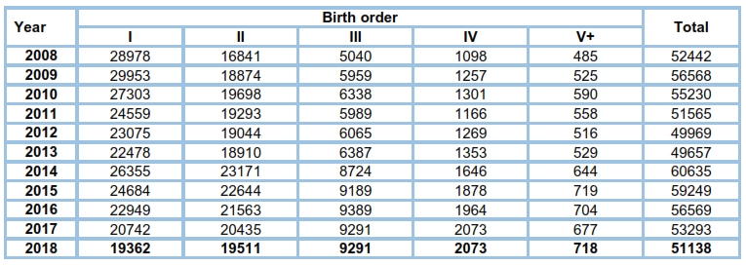

Total fertility rate (TFR)
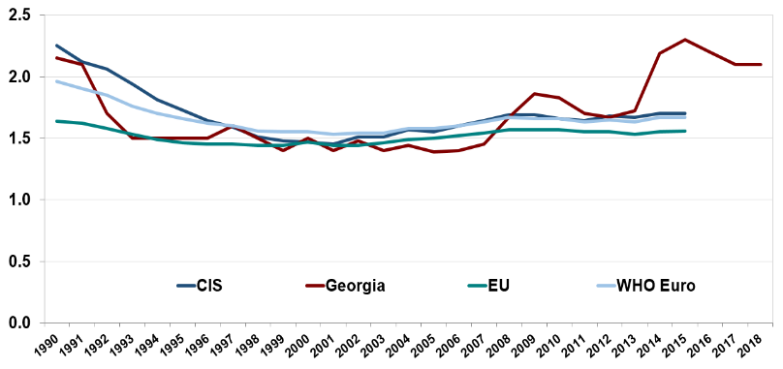
Source: National Statistics Office of Georgia

Births according to the National Statistics Office of Georgia, maternal and child mortality, Georgia

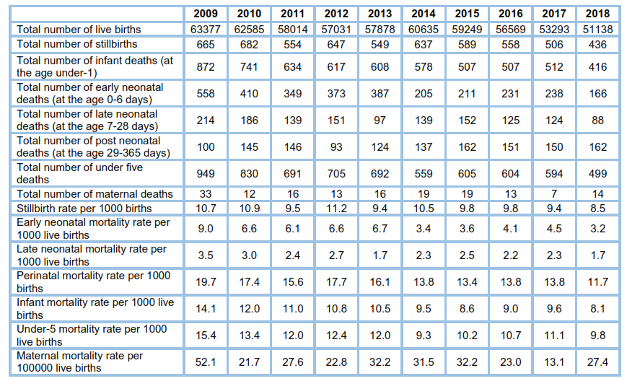

SDG 3.7 has been defined as universal access to sexual and reproductive healthcare services including to antenatal services. In 2018, according to the data collected from women consultancy centers, 64845 pregnant women were registered in Georgia. Last years, there was a growth of timely initiation of antenatal care (during the 1st trimester); this could be based on the improved financial accessibility of antenatal services.

Share of pregnant women (%) initiating antenatal care during the 1st trimester, Georgia

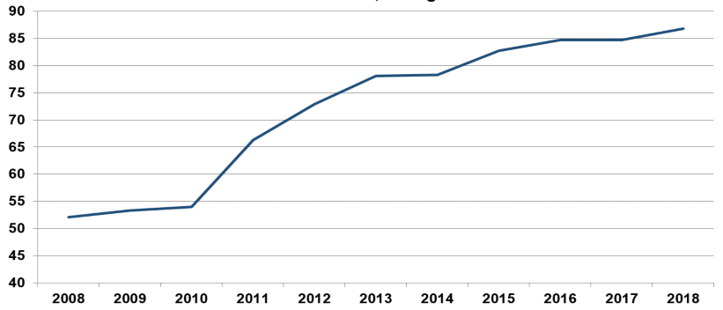

In 2018, 22733 abortions were registered (444.5 per 1000 live births) (Figure 6.2), of which, induced abortions constituted 61.9%. Compared with the previous year, the total number of abortions decreased by 9%.

Abortion

Induced abortion ratio per 1000 live births
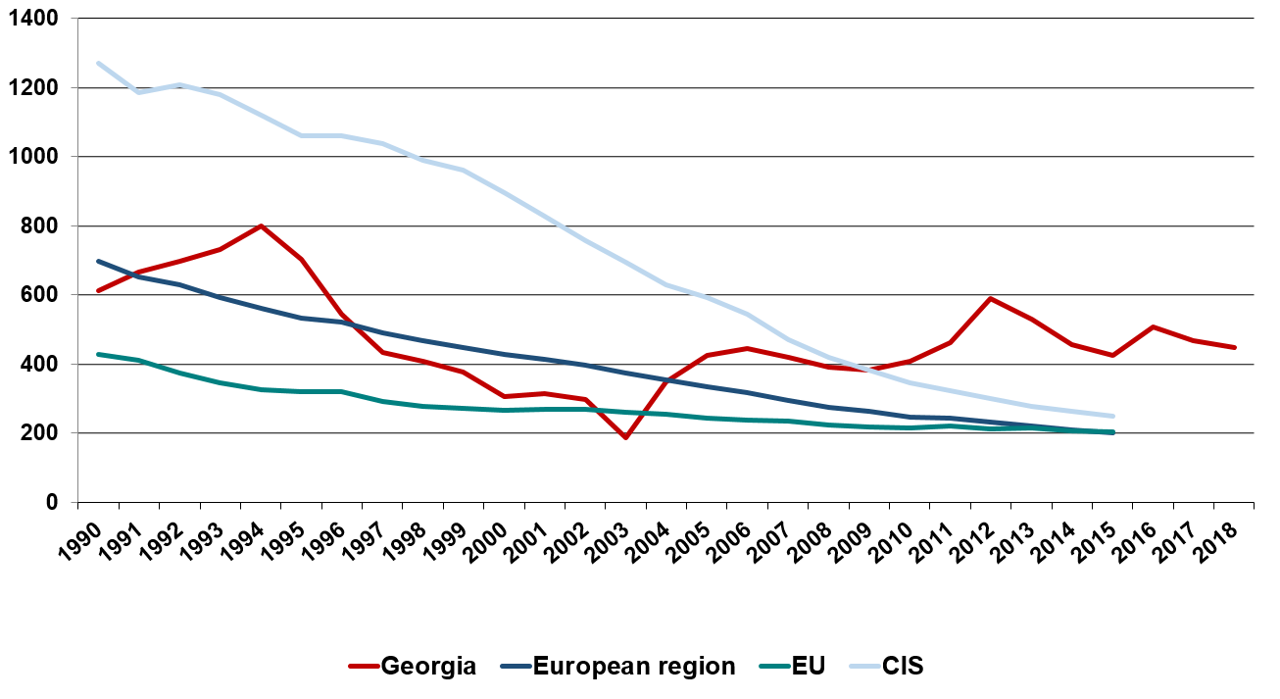
Source: NCDC; WHO HFA DB

Abortions, Georgia
In 2014, the Ministry developed a package of abortion regulating mechanisms that includes the following documents:
- On amendment to the Law of Georgia on Health Care (related to increase of deliberation period before an abortion to 5 days)
- ,,National protocol on safe termination of pregnancy“
- ,,Abortion procedure“ - patient version of the protocol
- Draft Order of the Minister of Labour, Health and Social Affairs on "approval of the rules for the artificial termination of pregnancy"
The issue of access to abortion will be regulated by the normative order of the Minister of Labour, Health and Social Affairs on "approval of the rules for the artificial termination of pregnancy", which determined the types of medical services (outpatient or inpatient) for abortions at different terms and by different methods; for example, in the period up to 7 weeks of pregnancy surgical termination is performed in an outpatient or inpatient facility by a physician-specialist - an obstetrician-gynecologist, while surgical termination of pregnancy after 7 weeks is performed only in an hospital-type facility that has a right to provide Obstetrics-Gynecological service. Medication abortion up to 10 weeks of pregnancy can be done in an outpatient facility. After 12 weeks of pregnancy abortion by any method is allowed only in case of medical and social indications and is performed only in hospital-type facilities that have a right to provide Obstetrics-Gynecological service.
When a health care provider for any reason, refuses to perform an abortion, in accordance with the "national protocol on safe termination of pregnancy" he/she is obliged to refer the patient to another facility providing the service.
Abortion complications are funded from the universal health care program.

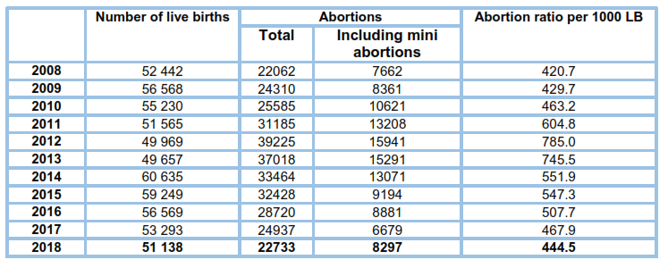

It is noteable that the share of abortions in women under-20 declined and reached 2.2% of the total number of abortions.

Abortions by age groups, Georgia, 2018
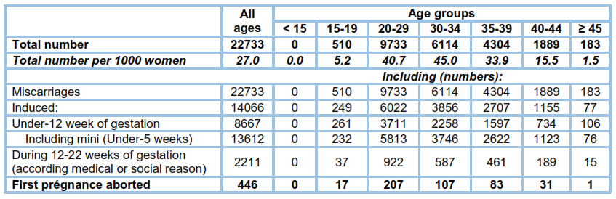

The total induced abortion rate (TIAR) is stable (fluctuates around 1) (Figure 6.3). The highest Induced abortion age-specific rates were registered in 20-29 and 30-34 age groups.

Total induced abortion rate (TIAR), Georgia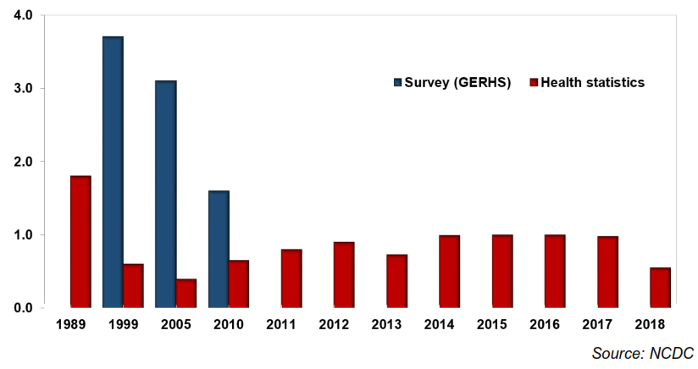

In 2018, the most common method of performing induced abortions was medication and its share is higher compare to the previous year.

Methods of induced abortions, Georgia
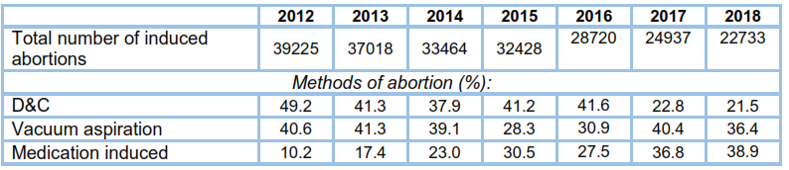

Delivery
In 2018, there were 50468 deliveries registered. Last years, the share of deliveries in health institutions, reached the maximum value and stayed unchanged.

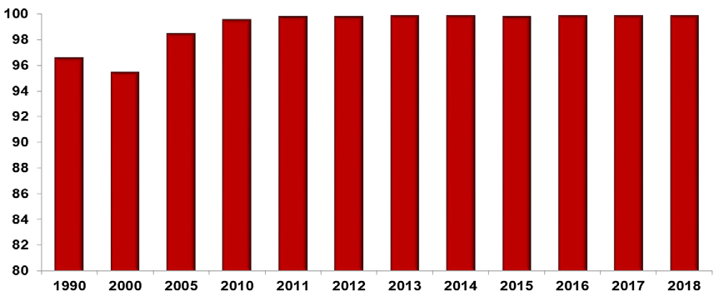
Source: NCDC

Adolescent pregnancy rate (rate per 1000 women aged 15-19
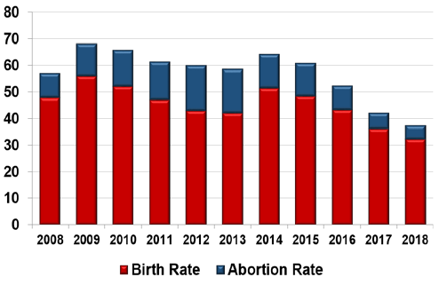
Adolescent pregnancy rate, Georgia
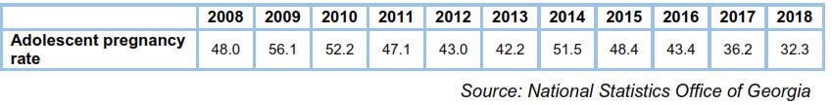

In 2018, 19.6% of deliveries were complicated by premature rupture of membranes, perineal laceration, 13.4% - by confirmed or suspected anomalies of pelvic organs. The share of the intrapartum and postpartum hemorrhage, eclampsia and pre-eclampsia, and sepsis were as follows: 2.5%, 2.4% and 0.2%, respectively.

According to the above sources, in 2018, there were 20 maternal deaths registered (due to
direct and indirect causes), including 14 early deaths (during pregnancy or within 42 days
from pregnancy termination). Maternal mortality ratio is 27.4 per 100 000 live births.

It is essential, that more than a half of maternal deaths were due to direct causes (13 cases): 2 cases (15.3%) caused by intrapartum and postpartum haemorrhage, 4 cases (30.7%) – by preeclampsy, 2 cases (15.3%) – by obstetric thromboembolism, 1 case (7.6%) – by pulmonary edema, 1 case (7.6%) – by undetermined death, 1 case (7.6%) – by rupture of uterus, 1 case (7.6%) – by post abortion bleeding.

Among indirect causes (7 cases) the following conditions are presented: 1 case (14.2%) of influenza, 1 case (14.2%) of subarachnoid hemorrhage, 1 case (14.2%) of thromboembolism, 1 case (14.2%) of acute respiratory failure, 2 cases (28.5%) of aneurysm and 1 case (14.2%) of breast cancer.

Two cases (14.2%) of early maternal deaths happened after a vaginal delivery, 9 cases
(64.2%) - after caesarean section, 1 case (7.1%) – after abortion, 2 women (14.2%) died in the course of pregnancy.

In the late maternal mortality structure, there are 2 cases (66%) of post vaginal delivery death, and 2 cases (34%) of post caesarean section death.

Maternal mortality by underlying cause of death of death, Georgia
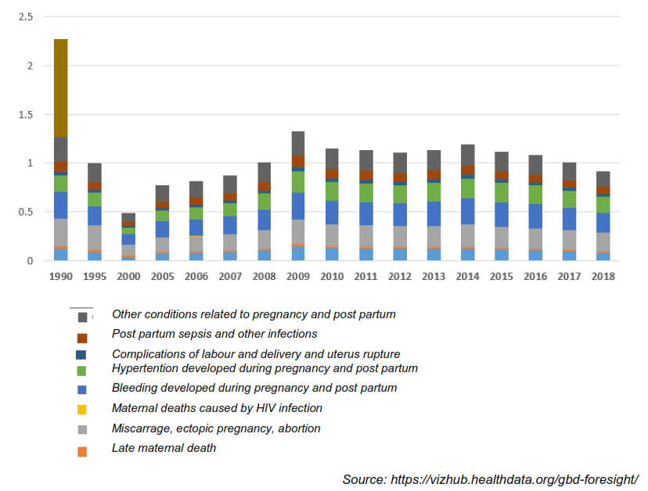
Incidence of diseases in newborns, Georgia, 2018
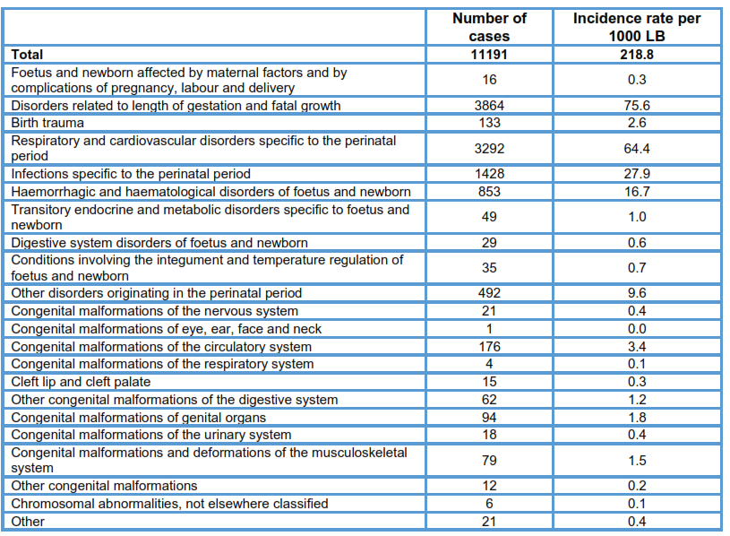

In 2018, in Georgia, 76603 new cases of diseases were registered in infants (in 2017 –
81158), incidence rate per 1000 infants – 1439.9 (in 2017 – 1481.0). A share of respiratory system diseases in infant morbidity was 57.7% (in 2017 – 61.9%), a share of infectious and parasitic diseases – 6.04% (in 2017 - 3.8%).

Morbidity of infants (most common causes), 2018
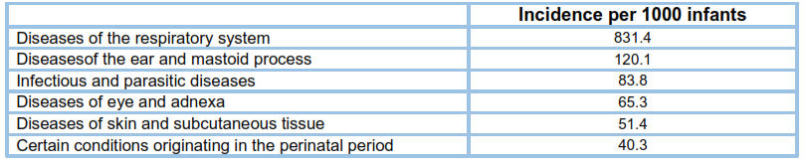

In Georgia, in 2018, a share of neonatal death in under-5 mortality was 50.9% (in 2017 – 58.9).

Neonatal and perinatal deaths, Georgia
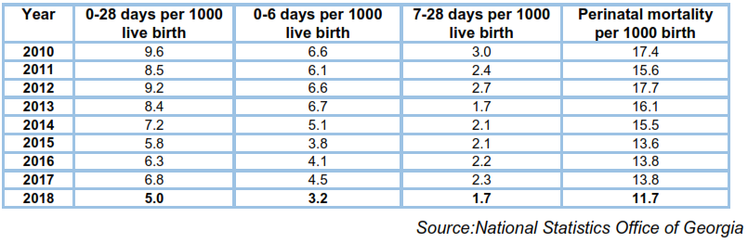

In Georgia, according to the latest available data in the WHO HFA DB, despite of the declining trend, the child mortality in children aged under-5, still is higher than in the European countries, although, it is in the middle position among the countries of the former Soviet Union.

In 2015, 5.8 million children aged under-5 died in the world. This is 52% less compared to 1990. During the same period, the neonatal mortality rate decreased by 42.2% and the stillbirth rate - by 47%. The reduction of mortality in children aged under-5 happened in 58 countries and, correspondingly, they achieved the MDG4 goal. It should be noted, that since 2000, 28 more countries have joined the above-mentioned successful countries.

According all sources, such as official statistics, international experts estimates (the UN Interagency Group for Child Mortality Estimation - IGME), and large-scale studies (Georgian Reproductive Health Survey GERHS), Global Burden of Disease Study – GBD, Georgia, has reached the Millennium Development Goal in reducing the under five mortality rate. It is important that GBDs and IGME assessments for the global and regional levels almost matched, the matching level - 98%.

c) If the previous conclusion was one of non-conformity, please explain whether and how the problem has been remedied. If the previous conclusion was deferred, please reply to the questions raised.

2. To provide advisory and educational facilities for the promotion of health and the encouragement of individual responsibility in matters of health

a) Please provide information about health education (including sexual and reproductive health education) and related prevention strategies (including through empowerment that can serve as a factor in addressing self-harm conducts, eating disorders, alcohol and drug use) in the community (life-long or ongoing) and in schools. Please also provide information about awareness and education in respect of sexual orientation and gender identity (SOGI) and gender violence.

Health prevention: The state program of health promotion has been functioning since 2016, the goal of which is to educate and raise awareness about the health of the population of Georgia, as well as to create a health-promoting environment, which allows for better control and improvement of health determinants.

The program includes activities in the following areas:
- strengthening tobacco control;
- education on healthy feeding;
- raising awareness about excessive alcohol consumption;
- promotion of physical activity;
- prevention of hepatitis C and promotion of education of the population;
- promoting mental health;
- prevention of substance abuse and gambling addiction;
- environment and health;
- Women's and mothers' health
- Promotion and strengthening of health promotion

Public healthcare programs: The aim of public healthcare program is supporting healthcare in the population, settling rules of healthy lifestyle, which is executed by different programs, helping to prevent many dangerous diseases, also arrangements to improve health state of the population.
Public healthcare includes programs, which help to prevent infectious and oncology diseases. Early detection of these diseases insures protection of the population to be increased from one point, and from the other point it ensures optimization of state expenses. Also immunization of the population, early detection of the diseases and support of screening programs, infectious diseases, like tuberculosis, malaria, hepatitis viruses, AIDS, and other infections, controlling their spread and making necessary arrangements to settle healthy lifestyle for the entire population of the country.
- Early detection of the diseases and screening supports settling rules of healthy lifestyle and early detection and prevention of spread of multiple diseases: cancer screening; screening of delays in children development in ages 0-6; early detection and prevention of Epilepsy.
- Immunization protects the population from controlled infections
- Epid-supervisory program improves epidemiological safety and epid-supervisory and laboratory services for infectious diseases
- Safe blood program – All donation have been All donation have been screened on HIV/AIDS, HCV, HBV and syphilis
- Professional diseases prevention program protects employees from professional diseases
- Infectious diseases management program ensure adequate in-patient hospitalization service in case of infectious diseases
- Tuberculosis Management program controls cases of tuberculosis in the country, persons with tuberculosis (including questionable cases) are insured with diagnostic and treatment possibilities.
- AIDS program controls AIDS infections in the country, persons with AIDS infection and also the persons of high risk group are insured with diagnostic and treatment possibilities.
- Mother’s and Children’s health program includes visits in the frame of antenatal observation; investigation of newborns on hypothyroid, phenilketonuria, hyperphenilalaninemia and mucoviscidoses; screening of pregnant women on genetic pathology; ensure adequate in-patient care for high risk pregnant, women in childbirth and after childbirth.
- Drug use prevention program - drug users are provided with drug replacing therapy and medical supervisory care; visits in-patient detoxication and rehabilitation purposes

b) Provide information on measures to ensure informed consent to health-related interventions or treatment and on specific measures to combat pseudoscience in respect of health issues.

According to Article 22 of the Law of Georgia on Patients' Rights, the necessary condition for providing medical care is to receive patient's informed consent. Written informed consent is essential for the following medical care:
- Any surgical operation, except for small surgical manipulation;
- Abortion;
- Surgical contraception - sterilization;
- Catheterization of major vascular vessels;
- Hemodialysis and peritoneal dialysis;
- Extracorporeal fertilization;
- Genetic testing;
- Gene therapy;
- Radiotherapy;
- Chemotherapy of malignant tumors;
- In all other cases, if the medical service provider believes it is necessary to write a written consent.
3. To prevent as far as possible epidemic, endemic and other diseases, as well as accidents.
a) Please describe the measure taken to ensure that vaccine research is promoted, adequately funded and efficiently coordinated across public and private actors.

Immunization: Restoration and expansion of routine child immunization has been significant achievement over the last 20 years. Immunization is a top public health priority from the point of view of the Government of Georgia. This is clearly proofed by a significant increase of funds allocated to the immunization program (4 million GEL in 2012 and 22,400 million GEL in 2018).

All vaccines included in the national immunization schedule are free of charge for the population. The State purchases vaccines, which are prequalified by the World Health Organization to guarantee that only high quality and safe vaccines are used for immunization of the population.

Vaccines against the following 12 diseases are currently included in the immunization schedule in the country: tuberculosis, hepatitis B, diphtheria, measles, tetanus, poliomielitis, measles, mumps, rubella, Hib (Hemophilus influenza), Rota virus, pneumococcal infection.

Last years, 5 new vaccines have been added to the immunization schedule: Rota virus vaccine - in 2013, PCV10 – at the end of 2014 (supported by GAVI), IPV (Penta vaccine replaced by Hexavalent vaccine) - in 2015, and the bivalent Polio vaccine (bOPV) - in 2016.

Since 2017, HPV vaccination of 9 year old girls has been launched in 4 regions of Georgia (Tuberculosisilisi, Kutaisi, Adjara, Abkhazia). Since August 2019, 10-11-12 year old girlswould be vaccinated with HPV. All vaccines included in the national immunization schedule are free of charge for the population. The State purchases vaccines, which are prequalified by the World Health Organization to guarantee that only high quality and safe vaccines are used for immunization of the population.

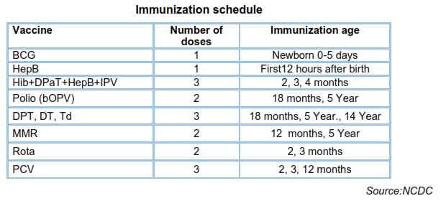

In 2018, immunization coverage rates are significantly higher than in previous yesr, especially Hep B (93.6% - in 2017, 96.4% - in 2018), MMR1 (95.5% - in 2017, 98.7% in 2018), MMR2 (89.9% - in 2017, in 2018 - 95.7%), Td (76.0% - in 2017, 88.3% - in 2018).

Immunization coverage rates (percentage), Georgia, 2018
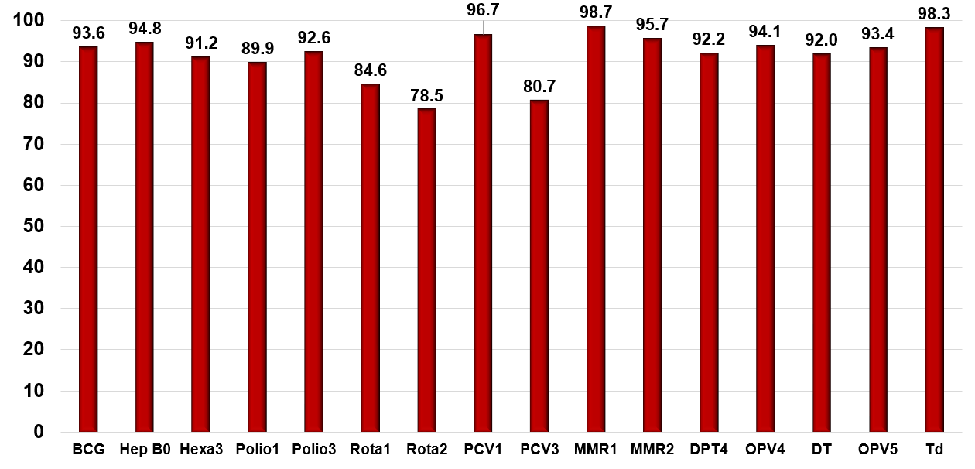
c) Please provide information on the availability and extent of community-based mental health services and on the transition to community-based mental health from former large-scale institutions. Please provide statistical information on outreach measures in connection with the mental health assessment of vulnerable populations, including those in a situation of poverty or exclusion, the unemployed (especially long-term unemployed). Provide also information on proactive measures adopted to ensure that persons in need of mental health care are not neglected.
In order to improve the coordination and supervision process of state policy in the field of mental health, there was created a Council for Mental Health Policy in 2013. The same year, the Parliament of Georgia approved a State Concept on Mental Health Care and in 2014 “National Strategy and Action Plan (NAP) for 2015-2020 was adopted by the Government of Georgia which sets strategic objectives and policy directions for improving mental healthcare system in Georgia.
A Program on Mental Health operates under the State Healthcare Program, adopted annually by the Decree of the Government of Georgia. The Program aims at increasing geographic and financial accessibility of the population of Georgia to the psychiatric services. The Program provides for an outpatient psychiatric services, psycho-social rehabilitation, short-term interventions in psychiatric crises, with services of the community-based mobile team for persons with severe mental disorders, acute and long-term psychiatric inpatient services for children and adults, shelters for persons with mental disorders. The program provides the patients with treatment and additional services (safety and security), where there is a court decision concerning person's hospitalization for coercive psychiatric treatment, based on Article 191 of the Criminal Procedure Code of Georgia.
The Ministry of Health is making efforts in the following directions: Improving the infrastructure of mental health care institutions; Protecting the rights of beneficiaries in mental inpatient facilities; Decentralization of mental health services and raising public awareness to reduce stigma towards people with mental health problem.
As a result, the principles under pinning the organization of mental healthcare systems have shifted away from a reliance on long stay institutional care in asylums (esailems), where the overarching concern had been to protect society from potential “harm”, to a system where the bulk of care is being provided through the development of community-based centers and mobile teams to help support people with mental health problems.

From 2018, Financing of community-based services has been increased. In particular, 54% of the budget resources has been directed to community-based services and throughout the country about 31 community-based mobile teams is functioning and as a result, more beneficiaries are able to use the mobile services in Tbilisi and in the regions as well.

In 2019, shelters for 24 beneficiaries were launched in Batumi. It is planned to launch four more new shelters this year. Small family-type homes for six beneficiaries began operating this year.

As part of the technical assistance provided by the French Agency for International Development, the process of reviewing, updating and harmonizing the legislation on mental health legislation with the EU legislation is underway. The main focus is on the detention of persons with mental disorders, their treatment, care for them, the mechanisms of appeal, as well as the legislation and regulations related to guardianship.
Healthcare and Social Issue Committee of the Parliament of Georgia and Ministry of health in collaboration with nongovernmental organizations and experts prepared amendment to the Law of Georgia on “Psychiatric Care”, which envisages introduction of the new services and monitoring as well as assessment mechanisms that will gradually address existing challenges in terms of the protection of the rights of patients/beneficiaries.

At the next stage the “WHO Quality Rights Tool Kit” will be the basis of internal inspection and monitoring mechanisms. In the March-May of 2019, 11 psychiatric hospitals were evaluated by this questionnaire. Currently, outpatient facilities are being monitored with a WHO questionnaire.

The process of improving the infrastructure of psychiatric facilities has started and continues since 2016. The reabilitation of Bediani and Surami clinics have been completed. New buildings were built at the Naneishvili Mental Health Center. The psychiatric ward of Batumi Medical Center was rehabilitated. Measures for reconstruction and equipment of 2 psychiatric hospitals are planned in Tbilisi.

Since 2019, funding of the residential program in the Psychiatry by the state will become possible within the framework of postgraduate medical education. This will resolve the problem of lack of doctors in the facilities benefitting the psychiatric services.

In 2018, by the end of the year 76508 cases of mental and behavioral disorders were registered by outpatient-clinics of Georgia (prevalence - 2053.1), this number included 3217 cases in children (prevalence - 429.1). There were 4859 new cases of mental and behavioral disorders registered, including 779 cases in children (incidence - 130.4 and 103.9, correspondingly).

Mental and behavioral disorders, morbidity rates, Georgia
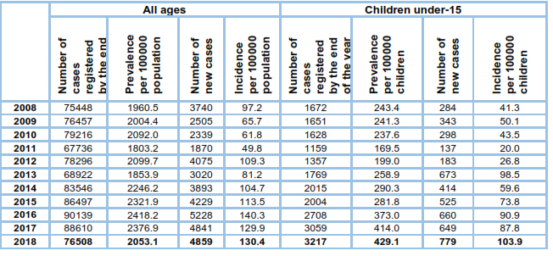

Mental and behavioural disorders by sex and age, Georgia 2018
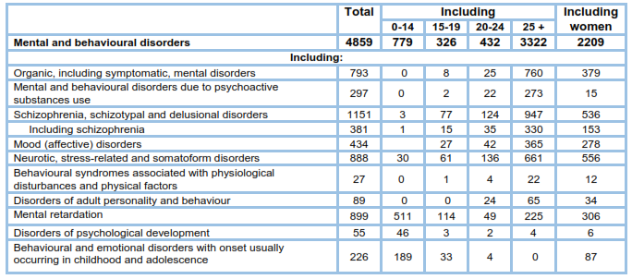

d) Please also provide information about drug-related deaths and transmission of infectious diseases among people who use or inject psychoactive substances both in the community and in custodial settings. Provide an overview of the national policy designed to respond to substance use and related disorders (dissuasion, education, and public health-based harm reduction approaches, including use or availability of WHO listed essential medicines for opioid agonist treatment) while ensuring that the “available, accessible, acceptable and sufficient quality” criteria (WHO’s 3AQ) are respected, subject always to the exigency of informed consent, which rules out, on the one hand, consent by constraint (such as in the case of acceptance of detox and other mandatory treatment in lieu of deprivation of liberty as punishment) and, on the other hand, consent based on insufficient, inaccurate or misleading information (i.e. not based on state of the art scientific evidence).

According to the latest integrated Bio- behavioral surveillance survey the estimated number of injecting drug users is 52,500. The rate of prevalence among adults (18-65 years old) is 2,24%. This is a rather high rate – Georgia come third after Seychelles and Russia with the number of problem drug users. It should be emphasized that there is a clear trend of a steady increase in the number of PWID – such survey has been conducted in Georgia since 2009 and every two years the number of people who inject drugs increases by several thousand people.

Buprenorphine (Subutex and Suboxone) and heroine, especially its cheap variety – raw heroine (not pure heroine) are leading injecting drugs. Compared to the previous waive of the survey (2014), Buprenorphine consumption has almost doubled, while the heroine consumption rate has slightly decreased; the level of use of homemade injecting drugs prepared through mixing different medications bought from pharmacies – so-called Krokodil (Desomorphine), Vint (Methamphetamine) and Jeff (Methcathinone) – has sharply decreased. And a new injection drug has appeared – the so-called ‘niddles’ (‘Ephedra Vint’, the injecting drug prepared from evergreen Ephedra bush needles having a stimulating effect).

As for non-injecting psychoactive substances, consumption of cannabis (marijuana) and psychoactive medications is still very common among this population. Basically, they use psychoactive drugs with a dizzying effect. It should be noted that compared to previous years the rate of use of these medications has decreased.
In terms of the risk of HIV infection, PWID behaviors are basically divided into two groups. These are risk behaviors related to drug injection and sexual behaviors. Compared to previous surveys, the proportion of safe injection became better in every city; the practice of sharing previousely used needles/syringes and other injecting equipment has decreased. As for a sexual behavior, condom use with paid and occasional sexual partner is high, however, using condom with a regular sexual partner still presents a problem.
It should be noted that the prevalence of HCV among PWI D is much higher compared to HIV. The average indicator of HIV prevalence has actually not changed since 2015; the survey revealed 47 confirmed HIV positive cases. The previous waives of the bio-behavioral surveillance survey also demonstrated a high prevalence of Hepatitis C virus.
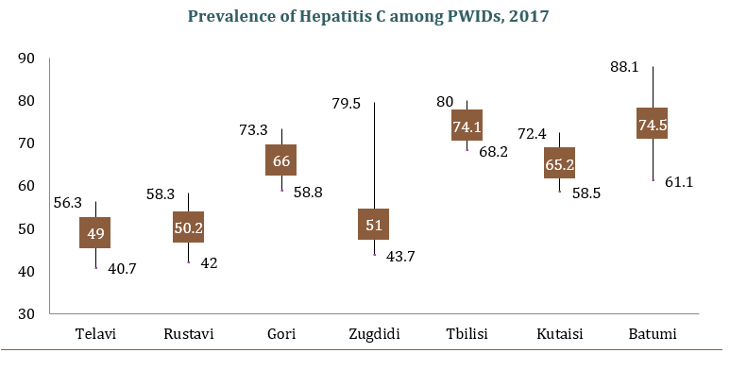
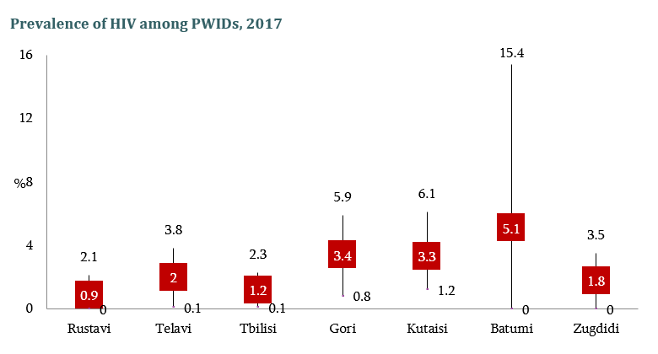
There is a state program for the treatment of drug addicts in the country. The services provided by the program include:
- Inpatient detoxification and first-line rehabilitation for opioids, stimulants, and other psychoactive substances in mental and behavioral disorders caused by consumption
- Implement replacement therapy and ensure the delivery of a replacement pharmaceutical product
- Providing psycho-social rehabilitation
- Inpatient services for mental and behavioral disorders caused by alcohol intake

e) Please provide information on measures taken to prevent exposure to air, water or other forms of environmental pollution, including proximity to active or decommissioned (but not properly isolated or decontaminated) industrial sites with contaminant or toxic emissions, leakages or outflows, including slow releases or transfers to the neighbouring environment, nuclear sites, mines, as well as measures taken to address health problems of the populations affected. Please provide also information about measures taken to inform the public, including pupils and students, about general and local environmental problems.

With the support of experts from WHO and EC Twinning GE 22 project "Strengthening the existing environment and health system in Georgia" was developed and approved the "Georgia National Environment and Health Action Plan 2018-2022 NEHAP-2.

The strategic objectives of the National Environment and Health Action Plan are:
1. Improving access to safe water and sanitation, including for each child;
2. Improving access to a healthy and safe environment to ensure increased physical activity for children and young people;
3. Reducing the harmful effects of air and indoor air pollution on the health of the population;
4. Prevention of illness caused by exposure to chemicals;
5. Integrate health issues into climate change adaptation and mitigation policies.

In cooperation with the Ministry of Environment Protection and Agriculture of Georgia, an air portal was launched, which was launched in January 2019 and on which public information on air quality monitoring was posted.
Outcomes and health recommendations for each contaminant according to international methodology.

The materials of the International Lead Prevention Week were prepared, a package of information for the lead biomonitoring protocol on the impact of lead exposure on humans, the sources of exposure and their prevention.

The MICS survey was conducted throughout Georgia with the support of the National Statistics Office of Georgia, the United Nations Children's Fund, WHO and DCJEC in order to protect the country from harmful exposure to the environment and prevent environmental diseases. The research round was expanded in terms of content and coverage, including a drinking water questionnaire, drinking water quality testing, and a blood lead study for children (blood lead studies for children ages 2-7) throughout Georgia. The children were included in the study on a random sampling basis and samples were sent for detection to the laboratory of the Italian Institute of Health. In the study of the blood sample on the lead content, the so-called the "gold standard" method is to measure the concentration of lead in the blood with an inductively coupled plasma mass spectrometer (ICP MS). According to the results, blood lead levels of 5 μg / dl were found in 41% of children, from 5 to 10 μg / dl in 25%, and> 10 μg / dl in 16%.

f) In the context of the COVID-19 crisis, please evaluate the adequacy of measures taken to limit the spread of virus in the population (testing and tracing, physical distancing and selfisolation, provision of surgical masks, disinfectant, etc.) as well as the measures taken to treat the ill (sufficient number of hospital beds, including intensive care units and equipment, and rapid deployment of sufficient numbers of medical personnel while ensuring that their working conditions are healthy and safe – an issue addressed under Article 3 above). Please indicate the measures taken or foreseen as a result of this evaluation.

In response to the rapid spread of infectious disease caused by the novel coronavirus (SARS-CoV-2) emerged in Wuhan (Hubei Province, China), on December 31st 2019 and for the prevention of the spread of COVID-19 cases in Georgia, the Government of Georiga took significant steps within a month before the first case of COVID-19 was confirmed.

Based on the recommendations of the World Health Organization and the U.S. Centers for Disease Control and Prevention, on January 31st, the definition of COVID-19 infection cases was approved and the country moved to active surveillance. Emergency operation center was set up at the National Center for Disease Control and Public Health.

From February 6 to February 14, various methodological recommendations and protocols related to COVID-19 were developed and approved, video lectures were launched and educational materials were circulated.

On March 16, the establishment of Clinical case management group of novel coronavirus (SARS-CoV-2) Infectious Disease (COVID-19) was approved, which developed a national guideline for the treatment of COVID-19.

Testing with PCR (polymerase chain reaction) method to detect COVID-19 in Georgia began on January 30 at the Richard G. Lugar Center for Public Health Research. The PCR method is considered to be a gold standard in the COVID-19 diagnostics. For today, 14 laboratories were conducting PCR testing.

In accordance with the recommendations of the World Health Organization, in February have conducted an assessment of hospitals readiness in terms of infection control and evaluated conditons and quantity of the ventilators and number of qualified medical staff. In total, 297 inpatient facilities (86% privately owned) operate across the country with 17,514 beds, out of which 2,290 are for intensive care and emergency medical services and own 2043 operating or reserved ventilators. 1749 are suitable for the management of respiratory distress syndrome. In total, 9000 beds were mobilized across the country to manage COVID-19.

In parallel with the preparation of the hospital sector, in order to prevent excessive utilization of emergency service by fever and respiratory symptoms patients and to effectively involve PHC settings in COVID management, a call forwarding service from emergency hotline 112 to family doctors has been set up. The MoIDPLHSA already has the practice of using this model during the flu pandemic.

In order to reduce the health risks to the population and spread of the infection, the government started creating quarantine spaces from March 4, which still ensures the placement of suspicious cases or the persons with high risk persons of the COVID-19. The quarantine zone includes 84 hotels across the country, bringing the total to more than 6,500 rooms. On March 23, the MoIDPLHSA determined terms and conditions of self-isolation/quarantine.

Epidemiological investigation group under the National Center for Disease Control and Public Health and the municipal Public Health Centers conduct on a regular basis contact tracing by compiling a "history of contact map" of the patient within 24 hours after the diagnosis of COVID-19 in order to identify people in contact with the confirmed case.

An application developed by the Austrian non-governmental organization NOVID-20 and the Austrian company Dolphin Technologies, as an important tool for COVID-19 infected patients’ contact traicing and prevention of the spread of the virus, is available in Georgia from April 16, 2020. The app allows users to find out if they have been in contact with a person infected with COVID-19.

Informational and educational materials were prepared, published and disseminated, including for ethnic minorities in Armenian and Azerbaijani languages; evidence-based educational materials from CDC, WHO and other international sources are being translated and adapted continuously. Visual materials, educational posts, infographics, video materials were developed and disseminated through the social network.

Proper management of hotline calls has significantly contributed to avoiding non-purposeful referral of patients to medical facilities. At the initial stage of the pandemic, under the conditions of informational shortage and panic, the majority of the population’s calls was being directed exactly to 116 001 (Hotline of the National Center for Disease Control and Public Health) and 1505 (Hotline of the Ministry of IDPs from the Occupied Territories, Labour, Health and Social Affairs of Georgia).

The Ministry of IDPs from the Occupied Territories, Labour, Health and Social Affairs of Georgia expresses special gratitude to all international partners (including governments of the United States, Germany, China, Japan, Korea, Estonia, Bulgaria, Lithuania, Czech Republic, Sweden, Great Britain, France, Turkey; and international/donor organizations: World Bank, USAID, CDC, DTRA, WRAIR, DOD, ODC, INL, IAEA, WHO, UNDP, UNFPA, UNICEF, UNHCR, IOM, EU, Global Fund to Fight AIDS, Tuberculosis and Malaria, Czech Development Agency, Czech Caritas, SIDA, KFW, GIZ/BMZ) for their efforts and support rendered to the Ministry to efficiently respond to COVID-19 pandemic.

Article 12 – The right to social security
GoG response:
To establish or maintain a system of social security:
Social protection system in Giorgia includes different support and assistance programmes for various vulnerable groups of people, including elderly, persons with disabilities (including children), households under the poverty line, orphans and other vulnerable groups. Cash assistance is given in the form of State Pension (retirement persons), State compensation (special groups), Social Package (persons with disabilities (including children), orphans, survivors, etc.) and non-financial social assistance: social services for elderly people, vulnerable children, including children lacking parental care, persons with disabilities / children, victims of domestic violence and abuse.
Every person living in Georgia is equal and protection of human rights is guaranteed by the Georgian legislation. Justice and impartiality are the main principles of decision-making for providing social security services.
Pension provision:
In order to ensure social protection and prevention of poverty in older, state provides all old age persons with social pension and carries out various social programs. The only condition for eligibility to the pension is age, for women - 60 and for men - 65. Amount of pension has increased over the years:
Year | Pension rate
2016 | 180 GEL
2017 | 180 GEL
2018 | 180GEL
2019 | 200 GEL
2020 | 220-250 GEL

From January 2020, pension increased from 200 to 220 GEL for all pensioners, while from July it increased up to 250 GEL only for the population aged 70 and over. Apart from that, amendment to the Law on, State Pension” introduced a new rule of indexation, in particular, from 2021 the pension for all pensioners will be increased not less than the inflation rate and in the case of retirees aged 70 and over, inflation will add up to 80% of real economic growth. At the same time, despite inflation and economic growth, the increase for pensioners under 70 will not be less than 20 GEL, for pensioners aged 70 and over - less than 25 GEL.
Based on the law “on the Development of the Mountainous Regions of Georgia”, from September 1 2016, pensions for persons permanently residing in mountainous regions of Georgia was increased by 20% of amount of the state pension.
State compensation

According to the Georgian Law on “State compensation and Academic Scholarship,” the state compensation is given to the persons, who have a special merit before the state. These are mainly the pensioners of military structures, former employees of the Ministry of Justice, former members and staff of the Parliament, former workers of civil aviation, judges of courts, persons possessing high rank of the diplomacy etc. With the increase of the state pension, the state compensation is automatically recalculated.
Subsistence allowance
In order to increase the effectiveness of the social protection system, in 2005 the Government of Georgia decided to move to a new system of social assistance, which maximized the distribution of state resources to the extremely poor and families, who need help first. The methodology for assessing the socio-economic situation of socially vulnerable families, which is used by Georgia, is the existing methodology in the world practice of welfare assessment - the so-called indirect method of estimating families, statistical model, formula, through which it is possible to rank families according to their well-being using different variables. The TSA scheme is a monthly cash benefit that specifically targets the poorest households. Eligibility is based on the score of a proxy means test (PMT). The PMT is the method used to estimate a household’s income – or means – using observable characteristics, such as geographical location and assets. The system (methodology) for assessing the socio-economic status of families has been revised several times.
Most recently, a new methodology was developed with the assistance of UNICEF and approved by the Government of Georgia by Resolution N758 of 31 December 2014, which came into force in 2015. The methodology focuses on household income (or income-generating property); accordingly, a recipient of a subsistence allowance may be a family that has no income or any kind of income-generating property, for example, extra flat, agricultural lands, and car. Household items such as refrigerator, washing machine, gas stove, water heater, air conditioner, TV, will not affect the rating scores. Subjective assessment of a social agent is no longer taken into account when determining rating points; in addition, the methodology takes into account the needs of the family itself, the special status of family members (a person with a disability, a person with a chronic illness, a minor, a pensioner, etc.).
As children are one of the most vulnerable part of the society and have more needs, in the methodology of assessing the socio-economic situation of socially vulnerable families, the coefficient of equivalence defined for them is also higher compared to other categories, which makes it possible to obtain a subsistence allowance. This is not surprising, because TSA is the task of covering vulnerable families. According to the new methodology, the social assistance is defined by the grading system: for families with a rating score of less than 30001 - the amount of subsistence allowance is 60 GEL per family member; for families with a rating score of 30001 to 57001 - 50 GEL per family member, for families with a rating score of 57001 to 60001 - 40 GEL per family member, for families with a rating score from 60001 to 65001 - 30 GEL per family member, and for families with a rating score of less than 100001 - subsistence allowance is set at 50 GEL for each member of the family under 16 years of age.
It should be noted that from March 2019 the child benefit is being issued in two different methods. In some municipalities, 30 GEL out of 50 GEL assistance is issued in the form of a "baby food card" (without the right of cash withdrawal) and 20 GEL in cash. In some municipalities, assistance is provided only in cash. UNICEF will assess which methodology is most effective and in which cases the child benefit is most used to meet the child's needs and only then will be determined in what form the benefit will be issued in the future.
From 2019 the subsistence allowance, for the families, registered in the database as vulnerable, receiving subsidy under 100001 rating score, will not be suspended during next 12 months even of salary existence of the family member (which is more than 175 GEL per member for 4 months), Child benefit (50 GEL per child); rating score will remain during 24 months in order to enable families to use non-monetary benefits, attached to the rating score.
It should be noted, that social transfers are one of the main means of combating poverty - "Surveys conducted by the United Nations Children's Fund (UNICEF) systematically show that any financial assistance available in Georgia reduces the child poverty." In addition, "if we subtract household expenditures, income from targeted social assistance, the level of extreme poverty among children will increase from 6.8% to 12.9%."
The results of the study show, that the targeted social assistance and child allowance have the greatest impact on children. "In the case of targeted social assistance and child allowance, 69.7% of the total allowance is paid to the poorest households, and 54.3% of these households receive it."
Social package
On July 23 2012, the Government of Georgia approved the resolution N 279 on “Social package”. The State Disbursement covers persons / children with disabilities, persons existing without breadwinner and the other specific categories. Amount of social package has increased over the years:

Year | Beneficiaries | Amount beneficiaries | Amount social package
2016 | Profound disabilities |  | 160- 180 GEL
2016 | Significant disabilities |  | 100 GEL
2016 | breadwinner |  | 100 GEL
2017 | Profound disabilities |  | 180 GEL
2017 | Significant disabilities |  | 100 GEL
2017 | breadwinner |  | 100 GEL
2018 | Profound disabilities |  | 180 GEL
2018 | Significant disabilities |  | 100 GEL
2018 | breadwinner |  | 100 GEL
2019 | Profound disabilities |  | 200 GEL
2019 | Significant disabilities |  | 120 GEL
2019 | breadwinner |  | 100 GEL
2020 | profound |  | 220-250 GEL
2020 | significant |  | 140 GEL
2020 | breadwinner |  | 100 GEL

In 2020, the amount of social package for persons with profound disabilities and for children with disabilities has been raised in two stages: In January, it amounted to 220 GEL, and from July to 250 GEL. The social package for persons with significant disabilities have been raised from 120 Gel to 140 Gel. The social package for the breadwinners is defined as 100 GEL.

From September 2016, residents of mountainous regions are entitled to receive social package, in addition of 20% of the state social package (Law on “Development of mountainous regions”).
Work injury
According to the decree N45 approved by the government of Georgia on 2013 March 1 – social assistance for the citizens of Georgia suffering from professional disease caused by work-related injury, who were employed by the enterprise created and managed by 100% participation by the Government ( with no replacement resource) on the territory of Georgia. Interagency commission takes the decision about the compensation.

Pursuant to the Georgian Legislation (,,Labour Code of Georgia”, ,,Civil Code of Georgia”, Law on “Medical and Social Appraisal” and Governmental Decree #45, March 1, 2013 on the “Rules of remuneration for damage caused to worker's health”) employers are responsible for providing employees with a safe work environment and if the damage to the worker’s health is caused by the fault of the employer which is affirmed by court, employer is liable to reimburse any damage.
Family benefit, Maternity benefit
By the resolution №262, on March 31, 2014, Government of Georgia approved “Demographic Situation Promotion Program”. The aim of the program is to improve the demographic situation in Georgia, especially in rural areas. Beneficiaries of the program are third or next children born after June 1, 2014, whose biological mother/family lives in the region, where annual average natural growth indicator is negative (mortality rate exceeds the birth rate). Amount of the benefit is 200 Gel in mountainous regions and 150 Gel in non-mountainous regions. According to the law on “Development of Mountainous Regions”, children born after January 1, 2016 whose one of the parents permanently resides in a mountainous region gained the right to receive the monetary social assistance. Amount of the assistance for the first and second child equals to 100 Gel per month and 200 Gel for the third and following child, until the child reaches 2 years old.
Also, since 2019 the families with multiple parental status (four or more children under 18), with rating score below 300 000, will receive monthly allowance for electricity in the amount of 20 GEL, and 10 GEL, for every following child.
Amount of the maternity benefit, for the whole period of leave from January 1, 2014 has increased from 600 Gel up to 1000 GEL. The benefit is funded by the state budget.
It is worth to mention also, that, very important support for families is, that kindergartens are free of charge for every child throughout the country and are financed by the municipal budgets.
Article 12§3
GoG response
Except to the above mentioned monetary programs, there are various support services in the country. In particular: taking into account the identified needs and existing priorities, the state implements the state program "Social Rehabilitation and Child Care", within the framework of which various measures are envisaged.

These programmes include: Assistance for families with children in crisis situations (Food and some household essentials), Early Childhood development services, Child Rehabilitation / Habilitation Services, Day care Centers for disabled children and disabled persons, Provision of supportive devices, foster care, shelters and day care centers for children living and/or working on the streets, family type homes for children lacking parental care, for disabled persons, for elderly, crisis center and shelters for victims of domestic violence/abuse, shelters for victims of humans trafficking and other programs.

The services and guarantees offered by the state are available and operate without any restriction and exceptions. The financial access to the number of services, the number of service providers, the number of financed courses and visits and the geographical area of service providers have been increased in recent years.
Within the framework of the state program, there are new services: "subprogram on urgent assistance for families with children in crisis conditions", "subprogram on homecare for children with severe and deep mental development retardation" (services are available in Tbilisi, Telavi and Zugdidi), "subprogram of specialized family type services for children with severe and profound disability or health problems” (Kutaisi, Tbilisi), a completely new component has been added to "subprogram of community organizations" - component of providing family-type independent lifestyle services for persons with disabilities. The quality and efficiency of sub-program activities for target groups enhanced and increased and consequently the participation of disabled people in public life has increased. The development of social services is based on the principle of availability of qualitative service adapted to the individual needs of the beneficiaries, which is strengthened by the proven and identified needs and the existing priorities.
The budget of the "State Program for Social Rehabilitation and Child Care 2019" has increased by 27% compared to last year's budget. The increase of the program budget is aimed at facilitating the process of deinstitutionalization and prevention of institutionalization; support and enhance services for children with disabilities and persons with disabilities; development of alternative care services close to the family environment. Funding for beneficiary services involved in various services has been increased under the increased budget. In addition, the number of limits set by the program have been increased (community organizations, day care centers, small family group houses), the number of funded visits, sessions and courses (early childhood development, rehabilitation / habilitation), as well as mobile groups (shelter for children lacking parental care).

In 2019, 2 mobile groups in Tbilisi and Rustavi were added to the sub-program "providing shelter for children lacking parental care". The rule for co-financing mechanical wheelchairs has changed. A new component has been added to the assistive device sub-program - providing a technical device (Smartphone) for the deaf and hard of hearing persons with a video conferencing function.

It should also be noted that in accordance with the amendment to the Law of Georgia on Adoption and Foster Care made on December 11, 2019, from February 1, 2020, a legal entity under public law - Agency for State Care and Assistance for the (Statutory) Victims of Human trafficking, was designated as a legal successor of LEPL - Social Service Agency for guardianship and custody, protection of children's rights and welfare within the powers granted to this agency by the legislation of Georgia. Thus make possible to formulate unified approaches to the issues of guardianship and child care.
The deinstitutionalization process is still ongoing.In 2020, with the support of the United States Department of Defense, one small family-type home was put into operation in Tbilisi for the beneficiaries of the orphanage, and it is planned to build 2 more houses.
The number of small family-type homes where minors receive services in a family-friendly environment has increased. There were 40 small family houses in the country in 2016, 41 in 2017, 44 in 2018, and 46 family houses in 2019-2020.
The deinstitutionalization process is a state priority. Our strategic goal is to minimize the number of children in institutions and eventually move them entirely to a new alternative, family environment (foster care, small family-type orphanage) and, if possible, return to their own biological family. Today, one of the top priorities of child welfare reform is to strengthen biological families and enhance their social functioning so that they can fully meet the needs of minor children.
To achieve this priority, the Ministry of Internally Displaced Persons from the Occupied Territories, Labour, Health and Social Affairs of Georgia, an agency, responsible for child welfare in cooperation with partner international and local NGOs, is gradually expanding its social service network throughout the country. At the same time, it increases the allocation of the state social program to ensure the development of needs-oriented services in various administrative-territorial units, as well as the number of target groups, so that all decisions related to children with disabilities are taken into account. When transferring children in alternative care services for the best interests of the children, 25 children with disabilities were placed in foster care in 2016, 1 was adopted and 1 was involved in the reintegration sub-program, and in 2017, 6 children with disabilities were placed in foster care, 1 child from Kojori Disabled Children’s House moved to a small family type home. In 2018, 8 children were placed in foster care, 3 were adopted, and 7 beneficiaries were enrolled in a small family-type home. In 2019, 9 children were placed in foster care from an orphanage, 7 were involved in the reintegration sub-program, and 1 was adopted. In 2020, 11 were placed in foster care from an orphanage, 2 were involved in the reintegration sub-program, and 1 was adopted. In 2020, 2 were involved in the reintegration sub-program from Kojori Disabled Children’s House.
In 2019, 83 beneficiaries were in LEPL State Fund for Protection and Assistance of (Statutory) Victims of Human Trafficking branches: 55 - Tbilisi Infant House, 28 minors - in Kojori Disabled Children’s House. IN 2020, 46 beneficiaries were in Tbilisi Infant House, 22 minors - in Kojori Disabled Children’s House.

It should be noted, that young people out of state care services were left without state support and it was difficult for them to start living independently. It is in this direction, that programs of financial support for young people aged 18-21 from the state care system and food programs for young people aged 18-21 from the state care system have been set up, which will be launched in 2021 and help young people start independent living.
Domestic violence
Since July 2016, the alleged recipient of domestic violence has been added to the circle of recipients of State Fund services. From June 2017, the services of the State Fund were extended to the victims / victims / alleged victims of violence against women and their dependents.

At present, there are 5 shelters and 5 crisis centers within Agency for State Care and Assistance for the Victims of Human Trafficking.

"Child Protection Referral Procedures" have been introduced, which define the relevant institutions of the Ministry of Internally Displaced Persons from the Occupied Territories, Labor, Health and Social Affairs, Education, Science, Culture and Sports of Georgia, the Ministry of Internal Affairs of Georgia, and the Ministry of Justice of Georgia. Legal entities of public law under the state control / governance of these ministries, the Prosecutor's Office of Georgia, coordinated work between the relevant bodies / institutions of the municipality, in case of child abuse, effective and rapid response mechanisms, which are related to the protection of children’s rights and best interests.

In 2016, the hotline within the State Fund (2 309 903) was replaced (Euro-number) by 116 006. From February 2017, the hotline became available for consultation on domestic violence, violence against women, human trafficking and sexual violence. The consultation hotline (116 006) operates 24/7, which provides recording of conversations, receiving several telephone calls simultaneously, arranging a conference for 3 people. From 2017, access to the hotline, in addition to Georgian, is provided in 7 additional foreign languages (English, Russian, Turkish, Azerbaijani, Armenian, Arabic and Persian).Calling the hotline is free for customers.

On April 27, 2020, at the initiative of the Human Rights and Civil Integration Committee of the Parliament of Georgia and with the financial support of the United Nations Children's Fund, a "Child Help hotline" was established on the basis of the Care agency for the fight against the pandemic 111.

Hotline Concept:
- Consulting, responding to and monitoring child abuse, child health, and education, social and other child-related issues.
In order to protect the rights of children and to overcome improperly rigid social norms, the Child Help hotline 111 toll-free, identifies, assesses, responds to and monitors individual and situational risks on working days from 10:00 to 19:00, taking into account the best interests of the child.The hotline, based on the principle of one window and according to the needs of the child, connects the relevant governmental and non-governmental agencies. The hotline can provide psychological services for the child and the parent, both by phone and in person - in the form of counseling. Since July 2020, the Child Rights Hotline 111 has also been providing counseling for children and adolescents (under 25) of gambling, gambling addiction and substance abuse, providing psychological services and engaging in other rehabilitation programs.

A specialized hotline to help children and their families to receive the state services available in the country during the COVID-19 pandemic is being launched today. The hotline aims at responding to the immediate needs of children in Georgia during the COVID–19 pandemic. To reach the hotline, children and their families need to dial 111. The number is operational 24/7, and all calls from Georgia are free of charge. The hotline is a joint initiative of the Human Rights and Civil Integration Committee of the Parliament of Georgia, the Ministry of Internally Displaced Persons from the Occupied Territories of Georgia, Labour, Health and Social Affairs and UNICEF. The Hotline is operated by the Agency for State Care and Assistance for the Victims of Human Trafficking.

Hotline operators will provide necessary consultations and refer children and parents to local service providers, municipalities and state agencies. The hotline will also respond to calls regarding violence against children. In these cases, psychologists will get involved and social workers, the police and other relevant agencies will be notified.

Measures, taken to compensate on any impacts of the COVID-19 crisis on social security system:

Significant measures have been taken in the field of social protection in order to deal quickly and effectively with the global coronavirus challenge. In particular, the following was implemented: continuous issuance of state benefits (state pension, compensation, social package, etc.), regardless of the grounds for suspension established by law, maintaining the legal force of the status of the disabled and continuing the social package, renewing the suspended subsistence benefits and ensuring the continuity of providing financial assistance to the families receiving the subsistence allowance, etc.

In order to prevent the spread of coronavirus in the country, the functioning of social services was suspended as part of preventive measures, however, due to the maintenance of social services, their funding continued according to certain principles. In addition, a framework document for remote delivery of services was developed, on the basis of which the provision of services to beneficiaries under various sub-programs (including early development support sub-program, child rehabilitation / habilitation sub-program, day care center sub-program, etc.) was continued.

"Recommendations to prevent the spread of the new coronavirus (COVID-19) in the workplace" was approved by the Order of the Minister of Internally Displaced Persons from the Occupied Territories, Labor, Health and Social Affairs of Georgia № 01-227 / O of May 29, 2020.Annex № 26 of the Order sets out recommendations for the registered service providers of several sub-programsof State Social Rehabilitation and Child Care Program.

“Standards for Prevention and Control of the Spread of New Coronavirus Infection (SARS-COV-2) (COVID-19) for 24-Hour Child Care Institutions (including Mother and Child Shelters) were approved by the Order of Minister of the IDPs from the Occupied Territories, Labor, Health and Social Affairs of Georgia.

In addition, the Minister of Internally Displaced Persons from the Occupied Territories, Labor, Health and Social Affairs of Georgia approved a "Conceptual Framework Document for Remote Delivery and Receipt of Social Rehabilitation Services for Children with Disabilities, Developmental Disabilities and / or Children Under 18" and "Standards for the Prevention and Control of the Spread of New Coronavirus (SARS-COV-2) Infection (COVID-19) to 24-Hour Child Care Facilities (Including Maternal and Child Shelters)". These documents define the principles of remote service delivery and monitoring mechanisms. These documents define common principles for staff and beneficiaries to act to prevent the spread of infection, as well as the principles of remote service delivery and monitoring mechanisms.

Resolution №286 of the Government of Georgia of May 4, 2020 approved the "Targeted State Program for Harm mitigation Caused by New Coronavirus (SARS-COV-2) Infection (COVID-19)", under which the right to receive state aid was obtained for a period of 6 months: 650001 - 100000 families with a rating score registered in the "Database of Socially Vulnerable Families" (according to the number of family members),The amount of compensation for single-member families is 70 GEL, for two-member families 90 GEL, In other cases, compensation have paid according to the number of family members, 35 GEL per family member. Also compensation have given up to 100,001 rating points families registered in the Database of Socially Vulnerable Families who have 3 or more children including 16 years old.

Under the above program, persons with severe disabilities and children with disabilities under 18 have resived100 GEL for 6 months in addition to the assistance provided by the social package.

Also, under this resolution, all children under the age of 18 received social assistance in the amount of GEL 200, as well as socially vulnerable students of higher education institutions (up to 150,001 rating points) were funded with one semester tuition fee in the amount of GEL 1125.

Article 13 – The right to social and medical assistance
GoG response:

1. to ensure that any person who is without adequate resources and who is unable to secure such resources either by his own efforts or from other sources, in particular by benefits under a social security scheme, be granted adequate assistance, and, in case of sickness, the care necessitated by his condition;

b) Please indicate any specific measures taken to ensure social and medical assistance for persons without resources in the context of a pandemic such as the COVID-19 crisis. Please also provide information on the extent and modalities in which social and medical assistance was provided to people without a residence or other status allowing them to reside lawfully in your country’s territory

Universal Health Coverage: Improving access to affordability and quality of healthcare services is the main priority for the Government of Georgia (GoG) that is reflected into an unprecedented, almost 3-fold expansion of budgetary allocation for health.
In February 2013, the GoG has launched the universal Health Care Program and has led to a major expansion in population entitlement to publicly financed health services.
The beneficiaries of the UHC program are persons holding citizenship document, neutral ID card, neutral travel document; persons with a status in Georgia without citizenship, refugees or humanitarian status holders. Population of Autonomous Republic of Abkhazia's, who possess the above mentioned documents, as well enjoy the State health care programs, as the rest of the population.

Universal Healthcare Program covers the basic package of planned and emergency in- and out-patient clinical care, including oncology and maternity services. State referral program covers cost of medical services and medicines to the individual needs of patients, which are not covered by other state health programs.

Article14 -The right to benefit from social welfare services
GoG response:
It should be noted, that according to the 2017 findings of the European Committee of Social Rights, there is no inconsistency with the first and second paragraphs of Article 14 of the European Social Charter.
Thus, we present only the requested information:
- A)
As already mentioned, significant measures have been taken in the field of social protection in order to deal quickly and effectively with the global coronavirus challenge. In particular, the following was implemented: continuous issuance of state benefits (state pension, compensation, social package, etc.), regardless of the grounds for suspension established by law, maintaining the legal force of the status of the disabled and continuing the social package, renewing the suspended subsistence benefits and ensuring the continuity of providing financial assistance to the families receiving the subsistence allowance, etc.
In order to prevent the spread of coronavirus in the country, the functioning of social services was suspended as part of preventive measures, however, due to the maintenance of social services, their funding continued according to certain principles. In addition, a framework document for remote delivery of services was developed, on the basis of which the provision of services to beneficiaries under various sub-programs (including early development support sub-program, child rehabilitation / habilitation sub-program, day care center sub-program, etc.) was continued.
"Recommendations to prevent the spread of the new coronavirus (COVID-19) in the workplace" was approved by the Order of the Minister of Internally Displaced Persons from the Occupied Territories, Labor, Health and Social Affairs of Georgia № 01-227 / O of May 29, 2020.Annex № 26 of the Order sets out recommendations for the registered service providers of several sub-programsof State Social Rehabilitation and Child Care Program.
“Standards for Prevention and Control of the Spread of New Coronavirus Infection (SARS-COV-2) (COVID-19) for 24-Hour Child Care Institutions (including Mother and Child Shelters) were approved by the Order of Minister of the IDPs from the Occupied Territories, Labor, Health and Social Affairs of Georgia.
In addition, "standards for the prevention and control of the spread of infection caused by the new coronavirus (SARS-COV-2) (COVID-19) in day care facilities for the elderly and disabled" were approved.These standards set out common principles for staff and beneficiaries to prevent the spread of infection.
In addition, the Minister of Internally Displaced Persons from the Occupied Territories, Labor, Health and Social Affairs of Georgia approved a "Conceptual Framework Document for Remote Delivery and Receipt of Social Rehabilitation Services for Children with Disabilities, Developmental Disabilities and / or Children Under 18".These documents define the principles of remote service delivery and monitoring mechanisms.
Resolution №286 of the Government of Georgia of May 4, 2020 approved the "Targeted State Program for Harm mitigation Caused by New Coronavirus (SARS-COV-2) Infection (COVID-19)", under which the right to receive state aid was obtained for a period of 6 months: 650001 - 100000 families with a rating score registered in the "Database of Socially Vulnerable Families" (according to the number of family members),The amount of compensation for single-member families is 70 GEL, for two-member families 90 GEL, In other cases, compensation have paid according to the number of family members, 35 GEL per family member. Also compensation have given up to 100,001 rating points families registered in the Database of Socially Vulnerable Families who have 3 or more children including 16 years old.
Under the above program, persons with severe disabilities and children with disabilities under 18 have resived100 GEL for 6 months in addition to the assistance provided by the social package.

Also, under this resolution, all children under the age of 18 received social assistance in the amount of GEL 200, as well as socially vulnerable students of higher education institutions (up to 150,001 rating points) were funded with one semester tuition fee in the amount of GEL 1125.

- B
Every person living in Georgia is equal, so defending the human rights guaranteed by the legislation of Georgia is being extended fairly to every citizen. Justice and impartiality are the main principals of decision-making for providing social security services.
Based on that, in order to implement the aims and functions the relevant authority of administration of the state outfits, LEPL Social Service Agency, and established in 2020 –LEPL - Agency for State Care and Assistance for the (Statutory) Victims of Human trafficking are being guided by the following principals: excluding discrimination based on social and property conditions, race, skin color, religion, gender, age and political affiliation. (At the same time, any events targeted to the people to ensure with special needs can’t be determined as discrimination. If they are determined as having physical disability, or having certain marital status/social conditions, they are assigned as people with need of special security and aid based on law of Georgia). (“Approval about the regulation of Social Service Agency-Legal Entity of Public Legislation’’. Ministry of Labour, Health and Social Affairs of Georgia Order N01-14 in 2018, 3 October, Resolution of the Government of Georgia of January 29, 2020 № 58 on the approval of the Statute of the Legal Entity of Public Law - Agency for State Care and Assistance for the (Statutory) Victims of Human trafficking).

At the same time, it should be noted that according to the amendment to the Law of Georgia on the Elimination of All Forms of Discrimination in 2019, the principle of equal treatment applies to social protection, social security, social benefits and others, among other issues. (Article 2, paragraph 10, sub-paragraph “c” of the Law of Georgia on the Elimination of All Forms of Discrimination).
Article 23
GoG response:
The Georgian side has not ratified the article 23; But Georgia would like to provide information on the legal status of older people on social protection.
In order to ensure social right and prevention of poverty in older, state provides all old age persons with social pension and carries out variety of social programs. The only condition for eligibility to the pension is age, for women - 60 and for men - 65.
In 2020, the increase in the pension rate was planned in two phases: from January, the increased amount of the state pension was from 200 to 220 GEL, and from July, the second phase of the increase in the state pension to 250 GEL was implemented again for the population aged 70 and over.
At the same time, according to the amendment in Georgian Law on ,,State Pension” there is established the new rule of pension indexation: from 2021 the pension of all pensioners will increase not less than the inflation rate and in the case of retirees aged 70 and over, inflation will add up to 80% of real economic growth. At the same time, despite inflation and economic growth, the increase for pensioners under 70 will not be less than 20 GEL, for pensioners aged 70 and over - less than 25 GEL.
According the State law on the “Development of high mountain region” from September, 2016, persons permanently living in the mountainous regions and having state pension/social package, get supplementary benefit which is 20% of the amount of the state pension/social package.
For elimination of the worst forms of poverty and social risks government implements Targeted Social Assistance (TSA) program. With the support of the United Nations Children's Fund a new methodology of assessment and cash transfers was for socially vulnerable families and was launched from 2015.New methodology is focused on the outcomes of the families. The family can get a subsistence allowance if it does not have any income or any income-generating property. As older people are considered to be among the most vulnerable group of the society and have more needs, the ratio of Equivalence (needs index) in the new methodology is very high, which makes this target groups eligibility for the subsistence allowance higher. Based on 2017 UNICEF’s Household Welfare Monitoring Survey, more than half of all households (58.9%) in Georgia include at least one person of pension age. In households with a single pensioner, the average total pension received constituted 61.3% of the mean consumption, and in households with more than one pensioner, it constituted 68.7%. If pension income was removed from household consumption, extreme poverty among pensioners would have risen sharply from 3.7% to 34.1%. The survey results suggest that pensions have the highest impact on pensioners.
In addition to the abovementioned, persons with disabilities receive social package. The state disbursement is given to persons with profound disabilities and to persons with significant disabilities. Categorical Benefits Significantly Reduce the Incidence of poverty. If categorical benefits were removed from household consumption, extreme poverty among households with a disabled person would have increased from 11.2% to 23.8%.
Under the resolution on "Targeted State Program for Harm mitigation Caused by New Coronavirus (SARS-COV-2) Infection (COVID-19)" approved the Government of Georgia families with a rating score 650001 – 100000, registered in the "Database of Socially Vulnerable Families" (according to the number of family members) receive the right to state aid for a period of 6 months. The amount of compensation for single-member families is 70 GEL, for two-member families 90 GEL, in other cases, compensation have paid according to the number of family members, 35 GEL per family member. Under the above program, persons with severe disabilities and children with disabilities under 18 have received 100 GEL for 6 months in addition to the assistance provided by the social package.

The state implements the state program "Social Rehabilitation and Child Care", within the framework of which various measures are envisaged. In order to support social integration and promote independent living for elder people, community-based services program is financed. The program implies accommodation, daily services, food, primary medical assistance, outpatient and inpatient medical care as well as Individual service program implementation according their preference and individual capacities; provision of clothes and personal hygiene products. Also, to improve functional independence and social integration of people with disabilities and older people, government funds assistive devices program, that includes provision of: wheelchairs, prosthetic and orthopedic products, canes, hearing aids, crutches.), In frame of "subprogram of community organizations" –is providing family-type independent lifestyle services for persons with disabilities. The quality and efficiency of sub-program activities for target groups enhanced and increased and consequently the participation of disabled people in public life has increased. The development of social services is based on the principle of availability of qualitative service adapted to the individual needs of the beneficiaries, which is strengthened by the proven and identified needs and the existing priorities.
Significant measures have been taken in the field of social protection in order to deal quickly and effectively with the global coronavirus challenge. In particular, the following was implemented: continuous issuance of state benefits (state pension, compensation, social package, etc.), regardless of the grounds for suspension established by law, maintaining the legal force of the status of the disabled and continuing the social package, renewing the suspended subsistence benefits and ensuring the continuity of providing financial assistance to the families receiving the subsistence allowance, etc.
“Standards for Prevention and Control of the Spread of New Coronavirus Infection (SARS-COV-2) (COVID-19) for 24-Hour Boarding houses of Persons with Disabilities and Elderly were approved. These standards set out common principles for staff and beneficiaries to prevent the spread of infection.
(SARS-COV-2) New Coronavirus Infection (COVID-19)", under which the right to receive state aid was obtained for a period of 6 months: 650001 - 100000 families with a rating score registered in the "Database of Socially Vulnerable Families" (according to the number of family members),the amount of compensation for single-member families is 70 GEL, for two-member families 90 GEL, in other cases, compensation have paid according to the number of family members, 35 GEL per family member. Also under the above program, persons with severe disabilities and have revised 100 GEL for 6 months in addition to the assistance provided by the social package.

Article 30
GoG response:
The Georgian side has not ratified the article 30; but Georgia we would like to provide information on the right to protection against poverty and social exclusion
As mentioned above, social protection system in Georgia includes different support and assistance programmes for various vulnerable groups of people, including elderly, persons with disabilities (including children), households under the poverty line, orphans and other vulnerable groups. Cash assistance is given in the form of State Pension (retired persons), State compensation (special groups), Social Package (persons with disabilities (including children) orphans, survivors, etc) and non-financial social assistance -the social services for elderly people, vulnerable children, including children lacking parental care, persons with disabilities / children, victims of domestic violence and abuse.
It should be noted, that Articles 12.1 and 12.3 describe in a detail the social protection measures implemented in our country. One of the most important measure to fight against poverty is to provide the population with a subsistence allowance
In order to increase the effectiveness of the social protection system of the population, in 2005 the Government of Georgia decided to move to a new system of social assistance, which maximized the distribution of state resources to the extremely poor and for families, who need help first. The methodology for assessing the socio-economic situation of socially vulnerable families, which is used by Georgia, is the existing methodology in the world practice of welfare assessment - the so-called indirect method of estimating families, statistical model, formula, through which it is possible to rank families according to their well-being using different variables. The TSA scheme is a monthly cash benefit that specifically targets the poorest households. Eligibility is based on the score of a proxy means test (PMT). The PMT is the method used to estimate a household’s income – or means – using observable characteristics, such as geographical location and assets. The system (methodology) for assessing the socio-economic status of families has been revised several times.
Most recently, a new methodology was developed with the assistance of UNICEF and approved by the Government of Georgia on Resolution N758 of 31 December 2014, which came into force in 2015. The methodology focuses on household income (or income-generating property); accordingly, a recipient of a subsistence allowance may be a family that has no income or any kind of income-generating property, for example, extra flat, agricultural lands, and car. Household items such as refrigerator, washing machine, gas stove, water heater, air conditioner, TV, will not affect the rating scores. Subjective assessment of a social agent is no longer taken into account when determining rating points; in addition, the methodology takes into account the needs of the family itself, the special status of family members (a person with a disability, a person with a chronic illness, a minor, a pensioner, etc.).
As children are one of the most vulnerable in society and have more needs, in the methodology of assessing the socio-economic situation of socially vulnerable families, the coefficient of equivalence defined for them is also higher compared to other categories, which makes it possible to obtain a subsistence allowance. This is not surprising, because the TSA is the task of covering vulnerable families.According to the new methodology, the social assistance is defined by the grading system: for families with a rating score of less than 30001 - the amount of subsistence allowance is 60 GEL per family member; for families with a rating score of 30001 to 57001 - 50 GEL per family member, for families with a rating score of 57001 to 60001 - 40 GEL per family member, for families with a rating score from 60001 to 65001 - 30 GEL per family member, and for families with a rating score of less than 100001 - subsistence allowance is set at 50 GEL for each member of the family under 16 years of age.
It should be noted, that the child benefit will be issued from March 2019 in two different methods. In some municipalities, 30 GEL out of 50 GEL assistance is issued in the form of a "baby food card" (without the right of cash withdrawal) and 20 GEL in cash. In some municipalities, assistance is provided only in cash. UNICEF will assess which methodology is most effective and in which cases the child benefit is most used to meet the child's needs and only then will be determined in what form the issuance of the said issue will continue in the future.
From 2019 for the families, registered in the database as vulnerable, receiving subsidy under 100001 rating score, subsistence allowance will not be suspended during next 12 months even of salary existence of the family member ((which is more than 175 GEL per member for 4 months), Child’s benefit (50 GEL per child) and rating score will remain during 24 months in order to enable families to use non-monetary benefits, attached to the rating score.
It should be noted, that social transfers are one of the main means of combating poverty - "Surveys conducted by the United Nations Children's Fund (UNICEF) systematically show that any financial assistance available in Georgia reduces the child poverty." Also, "if we subtract household expenditures, income from targeted social assistance, the level of extreme poverty among children will increase from 6.8% to 12.9%."
The results of the study show, that the targeted social assistance and child allowance have the greatest impact on children. "In the case of targeted social assistance and child allowance, 69.7% of the total allowance is paid to the poorest households, and 54.3% of these households receive it."
The table below provides information about persons registered in the database of Socially Vulnerable Families and recipients of assistance by the years.
Year | information about persons registered in the database of Socially Vulnerable Families | Recipients of assistance
2017 (december) | 975 236 | 455 813
2018 (december) | 946 297 | 435 450
2019 (december) | 927 993 | 427 373
2020 (octomber) | 993 935 | 510 343

Monetary suport taken to compensate on any impacts of the COVID-19 crisis on social protection system:
Resolution №286 of the Government of Georgia of May 4, 2020 approved the "Targeted State Program for Harm mitigation Caused by New Coronavirus (SARS-COV-2) Infection (COVID-19)", under which the right to receive state aid was obtained for a period of 6 months: 650001 - 100000 families with a rating score registered in the "Database of Socially Vulnerable Families" (according to the number of family members),The amount of compensation for single-member families is 70 GEL, for two-member families 90 GEL, In other cases, compensation have paid according to the number of family members, 35 GEL per family member. Also compensation have given up to 100,001 rating points families registered in the Database of Socially Vulnerable Families who have 3 or more children including 16 years old.
Under the above program, persons with severe disabilities and children with disabilities under 18 have resived100 GEL for 6 months in addition to the assistance provided by the social package.

Also, under this resolution, all children under the age of 18 received social assistance in the amount of GEL 200, as well as socially vulnerable students of higher education institutions (up to 150,001 rating points) were funded with one semester tuition fee in the amount of GEL 1125.

https://www.unicef.org/georgia/media/2491/file/TSA&CHILDPOVERTY_ge.pdf
https://www.unicef.org/georgia/media/1221/file/WMS%20GEO%202017.pdf
https://www.unicef.org/georgia/media/1051/file/WMS.pdf
https://www.unicef.org/georgia/media/1051/file/WMS.pdf
https://www.unicef.org/georgia/media/2491/file/TSA&CHILDPOVERTY_ge.pdf
https://www.unicef.org/georgia/media/1221/file/WMS%20GEO%202017.pdf

